**Project Final Phase**

**December 2, 2020**

**Prof. Rudolph Brown, CIS5800**

**Team 3:**

**Rudy Bi**

**Cinthia De La Cruz**

**Mamadou Diallo**

**Jackson Gable**

**Daphne Gao**

**Table of Contents**

*Executive Summary, Introduction 2*

*Deployment Plan 2-3*

*Release Plan 4*

*Production Environment 5*

*Diagrams and Models 6-11*

*Changes 12*

*Database Deployment 13*

*Rollout Plan 14*

*Communication Plan 15*

*Backout Plan 16*

*Business Continuity/Disaster Recovery Plan 16-17*

*Support/Maintenance Plan 18-19*

*Organizational Plan 19*

*Future Enhancements 19*

*Closeout Report 20-26*

*Product Release and Repository 26*

*Appendix A 27-28*

*Works Cited 29-30*

*Integrity Statement 31*

**Executive Summary**

Team 3 has put together this report in order to deliver a detailed summary of outcomes on our Online Ticket Booking System. In order to provide complete and fully comprehensive information, our team is providing multiple reports and plans which cover prior, current, and future project concerns and/or findings.

**Introduction**

Our team was hired by Team 3 TA to create and develop a website for users to search local and national events that would have the capability to reserve and purchase tickets. The website required the potential to save and store customer data such as billing and contact information in one safe and secure place.

The main objective was to retain customers and their loyalty thus providing the company with an increase in revenue.

**Deployment Plan**

**A. Deployment Goals and Success Factors:**

Although the main objective of our project was to create an online ticket booking system, in order for it to be viewed success and for our team to be confident enough to deploy it, it needed to be: accessible, safe and secure, user friendly, and it had to be able to store and save multiple user information. Below, we discuss all of these goals and their success.

* *Accessible:* Currently the website can only be reached via computers and laptops but would like to implement fute accessibility via smart devices
* *Safe and secure:* only designated website admins have the capability to access registered user’s information
* *User friendly:* website is pretty self explanatory and everything has been clearly labeled. All buttons and links work as intended and a customer support messaging system was also integrated to provide additional help when needed.
* *Data storage:* all registered users along with their credentials along with all events purchases information are able to be stored into our database

**B. Release Plan:**

|  |  |
| --- | --- |
| 1. **Release Item Information** | |
| Release name | **Team 3 TA Online Booking System** |
| Business description of release | **Initial website launch of ticket booking system.** |
| Technical scope of release | **Capability to easily search, save, purchase event tickets.** |
| Business justification | **To provide the digitalization of business in order to provide customers faster accessibility. Increase customer base, loyalty and business profit.** |

|  |  |
| --- | --- |
| 1. **Release Schedule** | |
| Go live date | **12/2/2020** |
| Release end date | **Site will remain active** |

|  |  |
| --- | --- |
| 1. **Release contact details** | |
| Release initiator (sponsor) | **Team 3 TA** |
| Release Manager | **Rudy Bi** |
| Team Responsible for release | **Team 3** |
| Project Manager | **Jackson Gable** |
| Project Technical Lead & Data Scientist | **Rudy Bi** |
| Project Team Lead & Scrum Master | **Daphne Gao** |
| Software Engineer | **Mamadou Diallo** |
| Technology Support Specialist | **Cinthia De La Cruz** |
| Website Domain | **https://**[**brooding-compositio.000webhostapp.com**](https://brooding-compositio.000webhostapp.com/)**/** |

**C. Production Environment:**

* + 1. ***Technology and estimated cost to operate the product***

***Technology:***

* XAMPP - localhost
* TEXT EDITOR
* phpMyAdmin
* Internet Browser

***Cost to operate site:***

* Team 3’s total cost to develop the website was[*$35,000*](https://www.letsnurture.com/how-much-will-it-cost-to-a-ticket-marketplace-app-like-ticketmaster.html)*.* This amount was determined and based on hourly rates of everyone involved in the project.
* It has been agreed upon by both parties (Team 3 TA and Team 3) that the data scientist, Rudy Bi will continue to support the ticketing agency should any issues arise. A contract has been signed where it is stated that Rudy Bi will be paid [$300](https://www.webfx.com/internet-marketing/big-data-consulting-rates.html) per hour to resolve any website problems encountered after release date.
* If needed, Team 3 will remain open to providing additional support if and when it is needed but only after payment agreements have been drafted and signed.
  + 1. ***Person(s) responsible for getting environment ready for deployment***
* On release date, Team 3’s data scientist along with the Project Manager will join Team 3 TA and their assigned website rollout team
* Prior to deployment date all 5 members of Team 3 worked synchronously to implement almost all required website features stated in the initial project report.
* Also prior to deployment, Team 3 TA created and trained their own set group of employees that was assigned to work on the website after the launching date.
  + 1. ***Network Diagram of production environment***

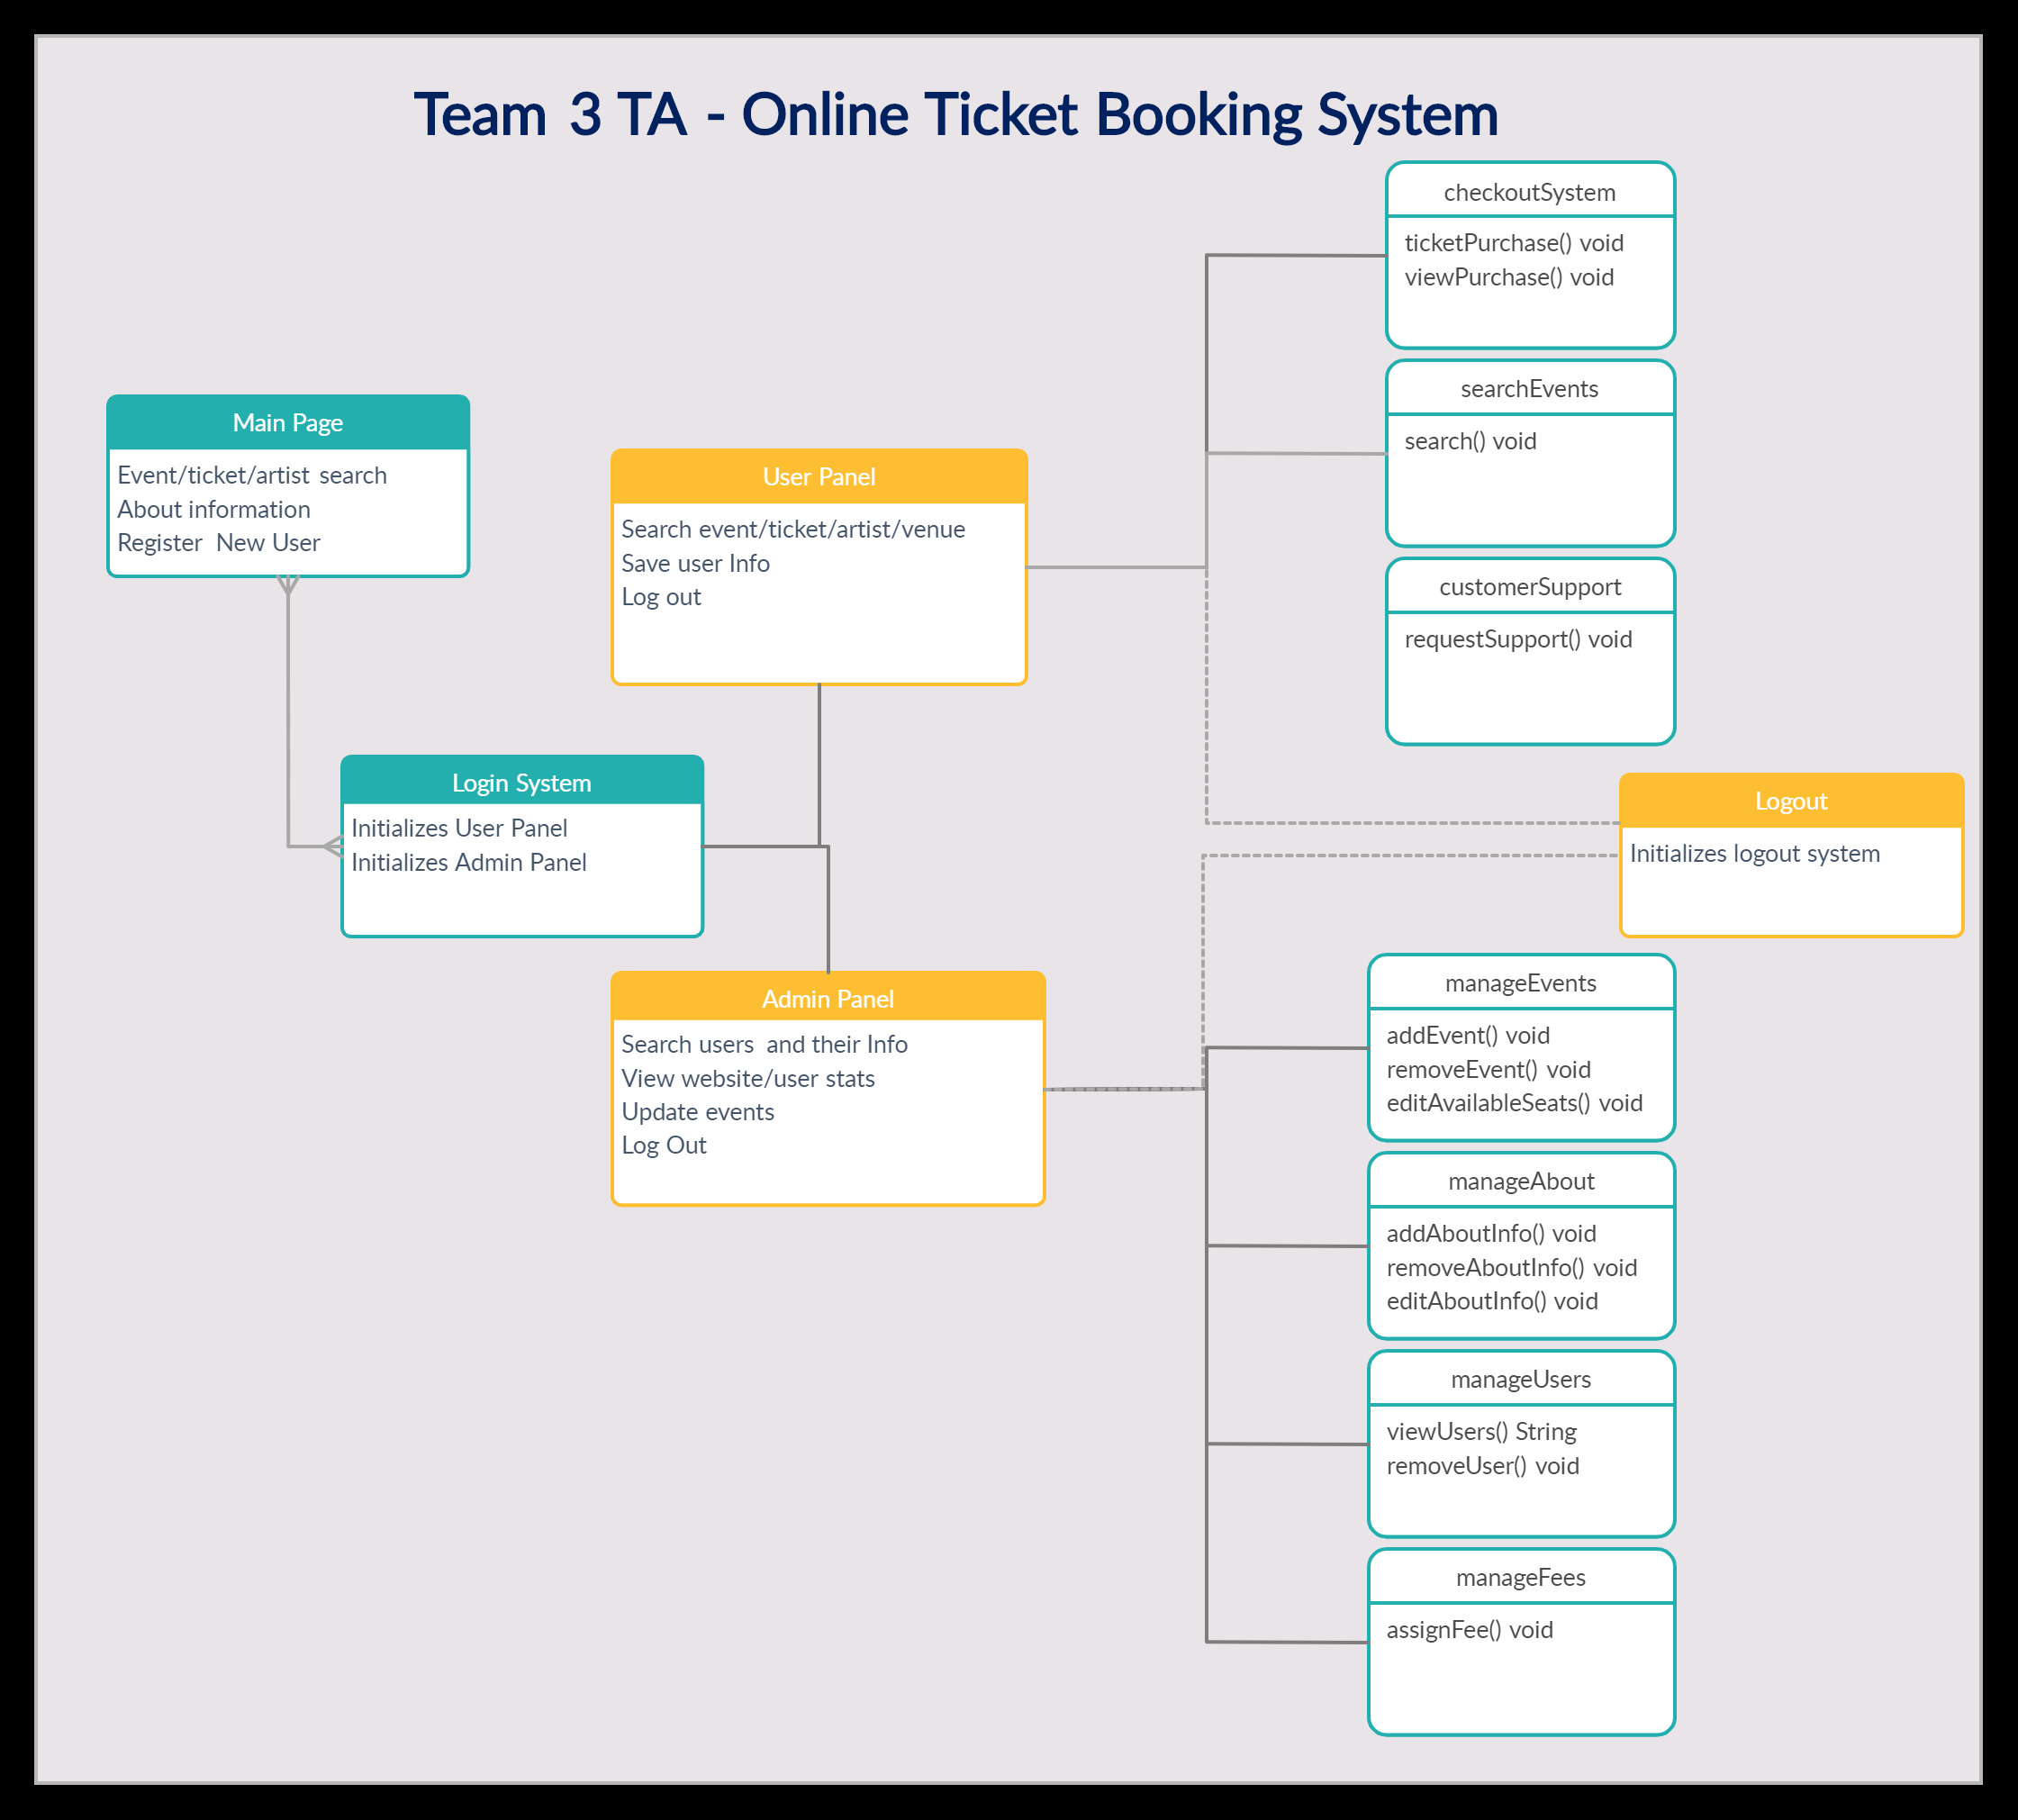

**Original Analysis Model**:

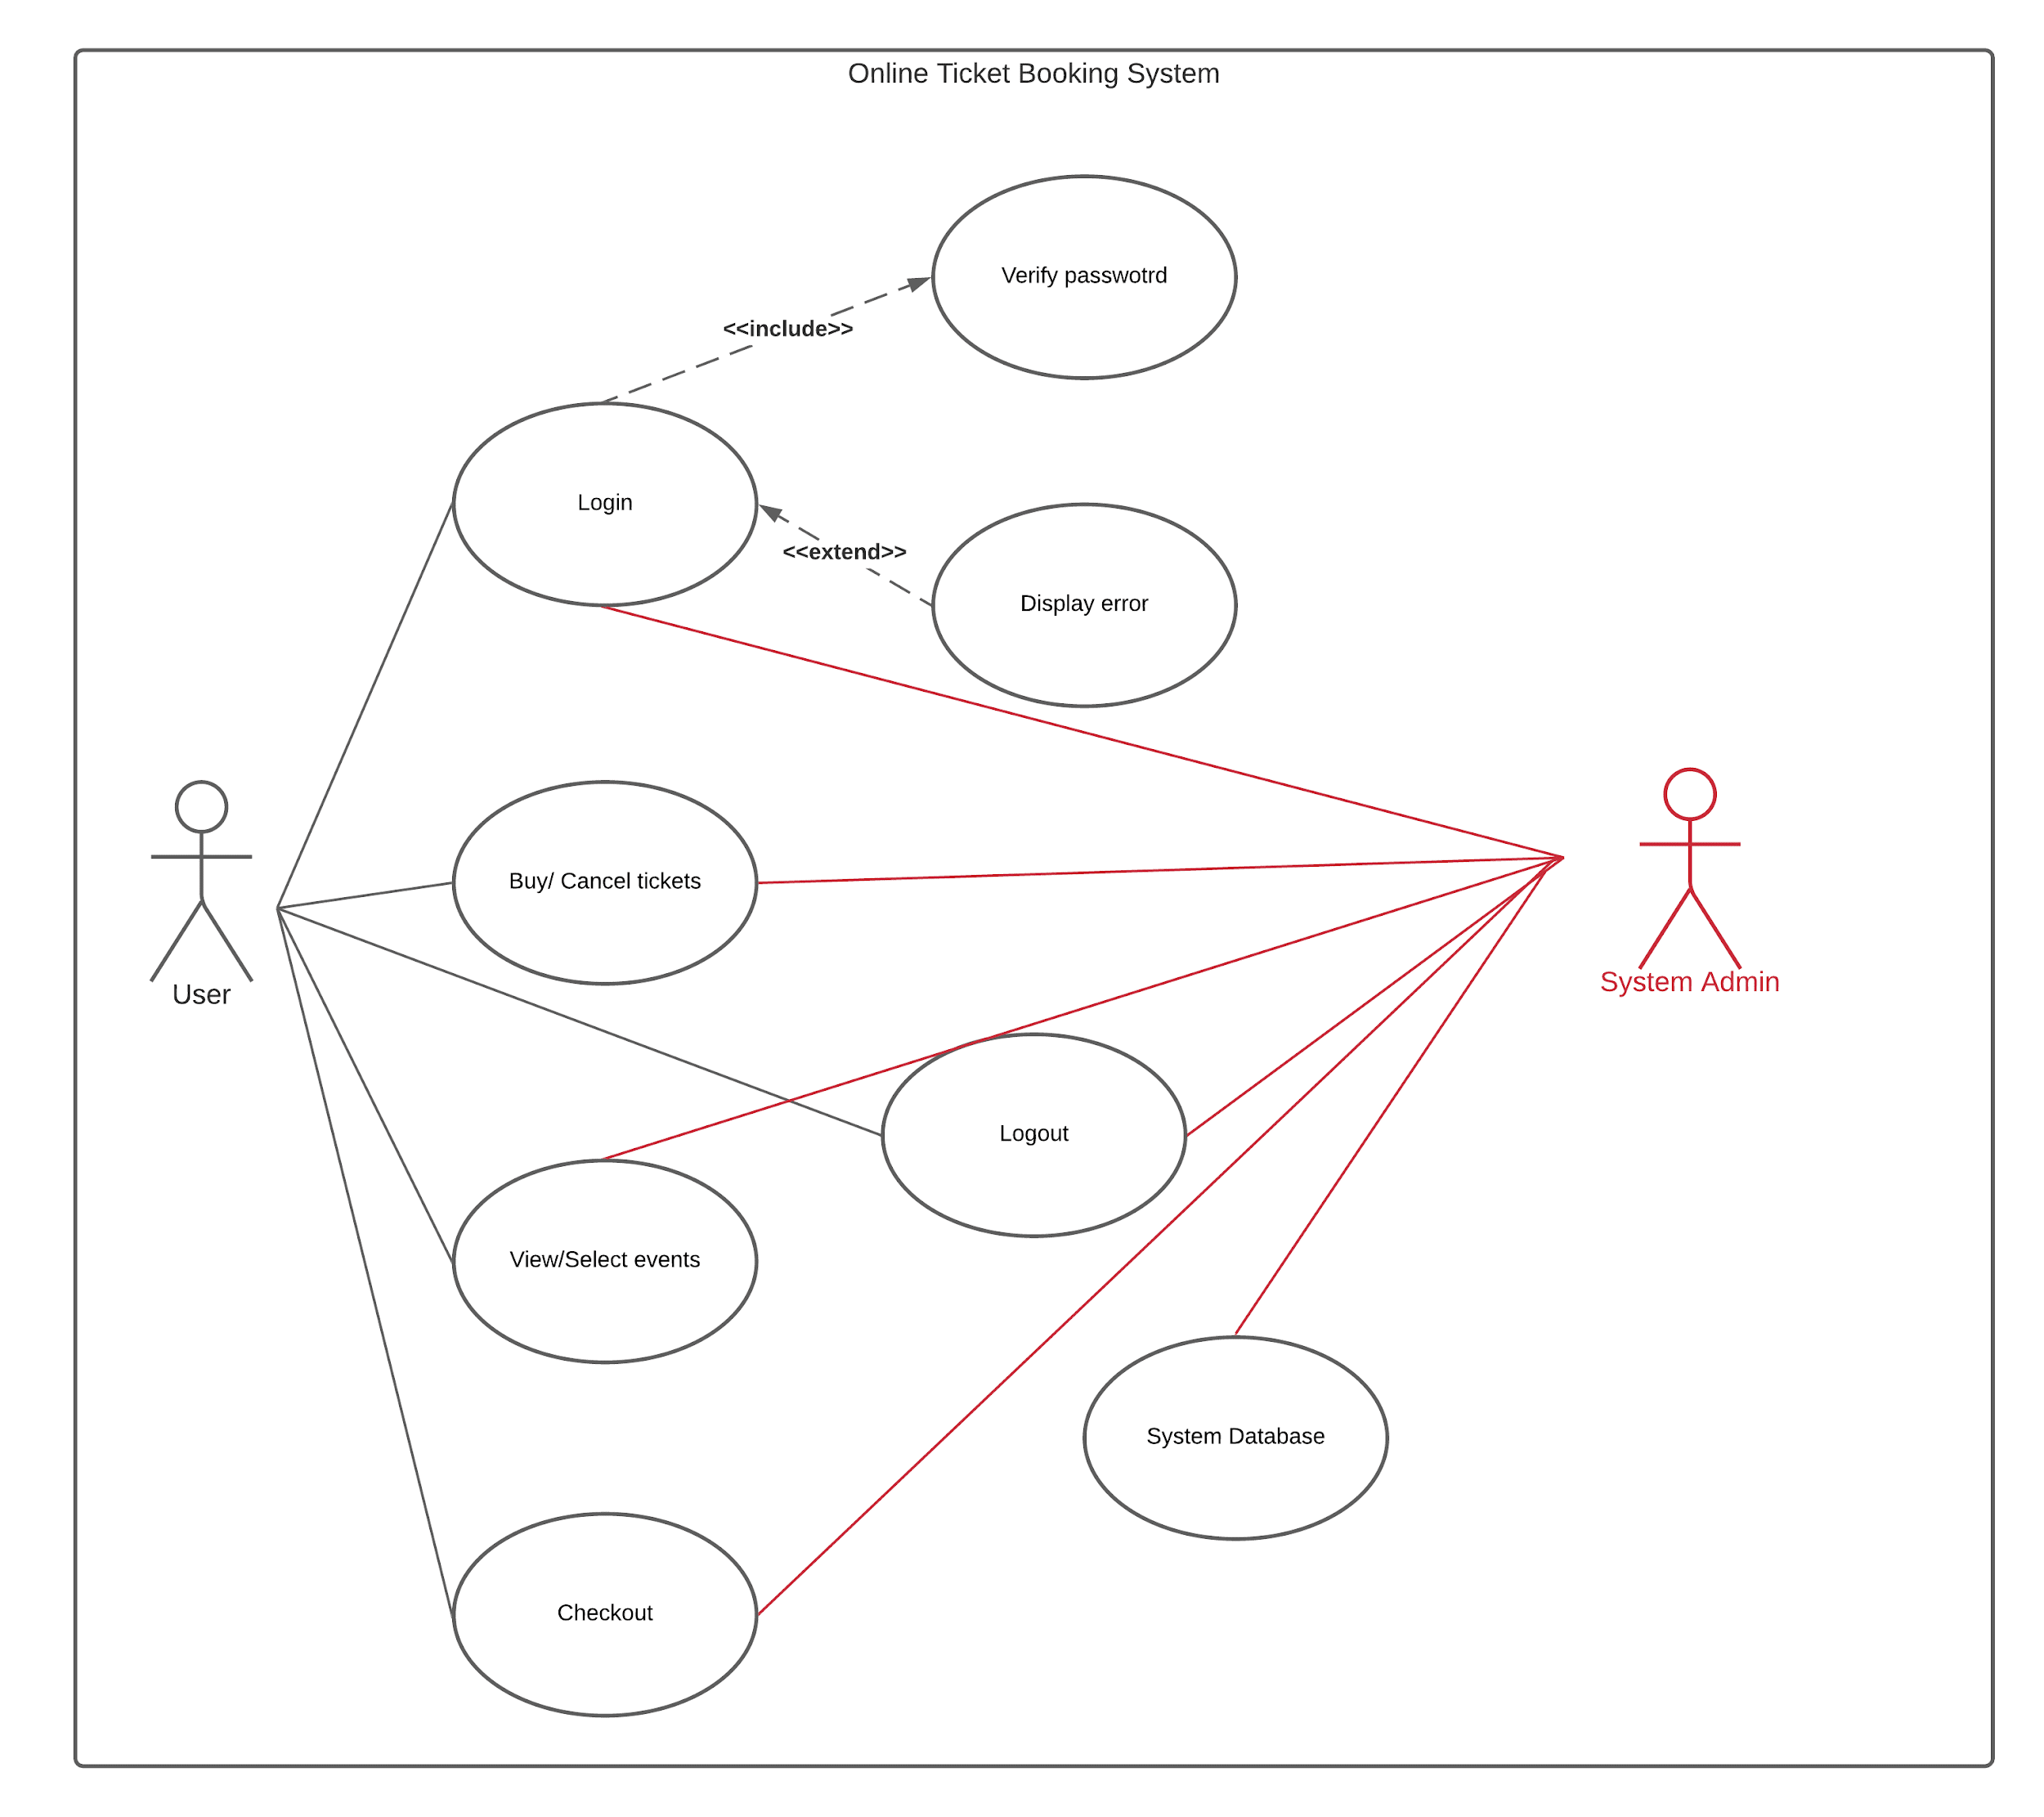

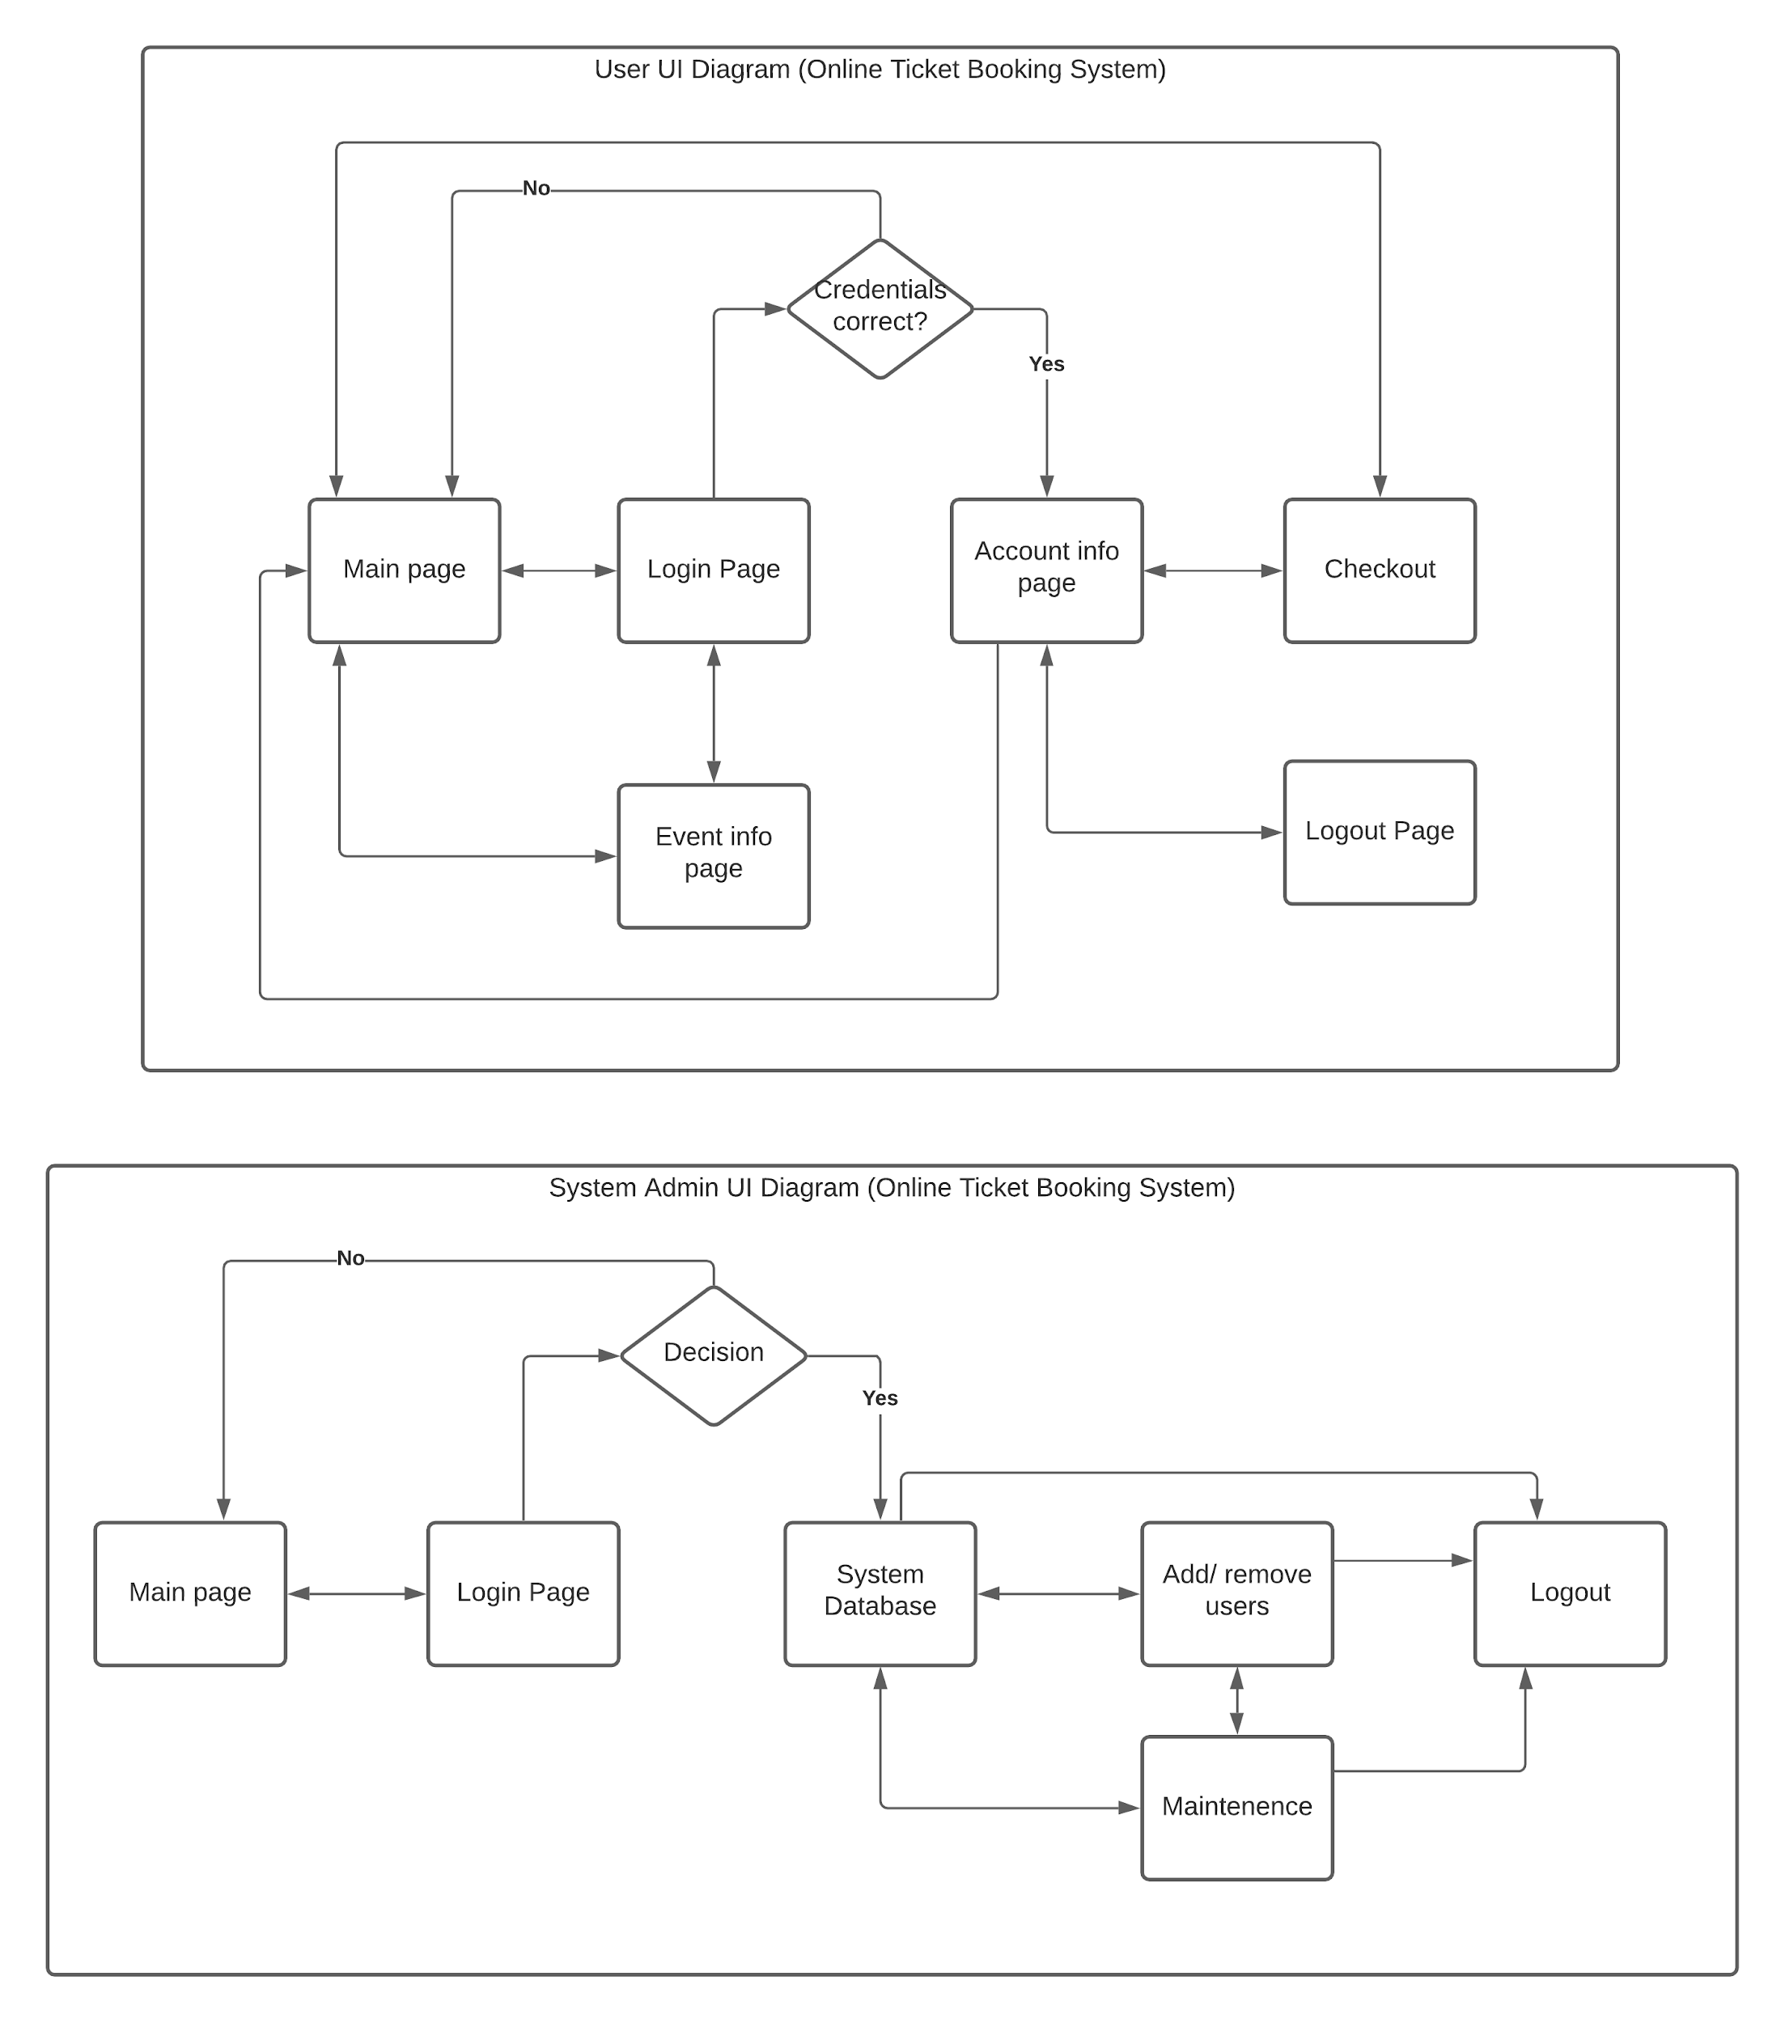**Original UI Flow:**

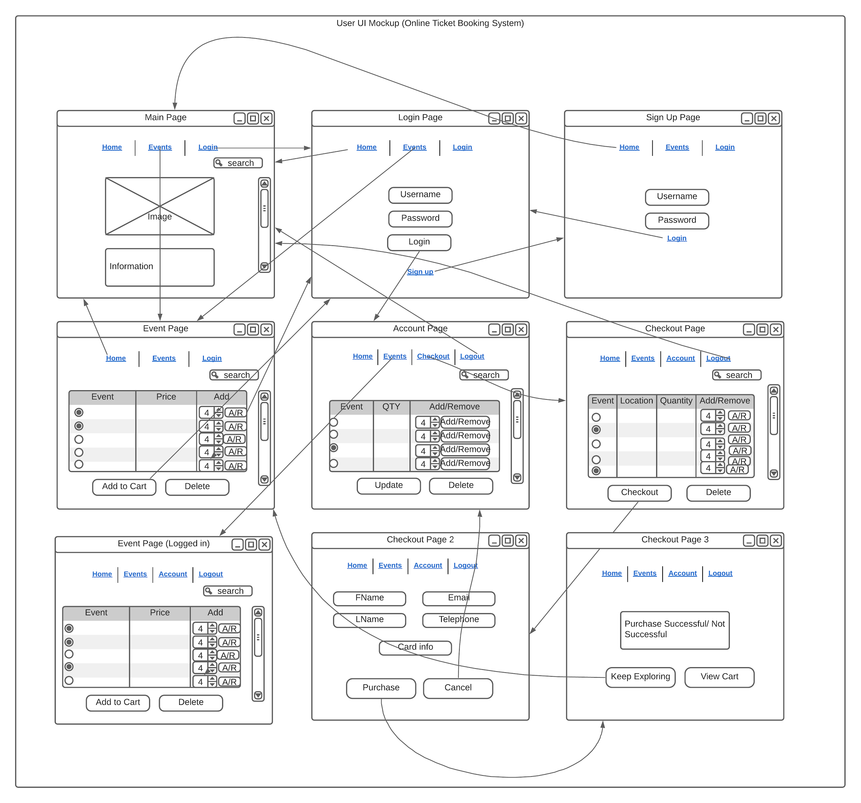

**Original UI Design (User):**



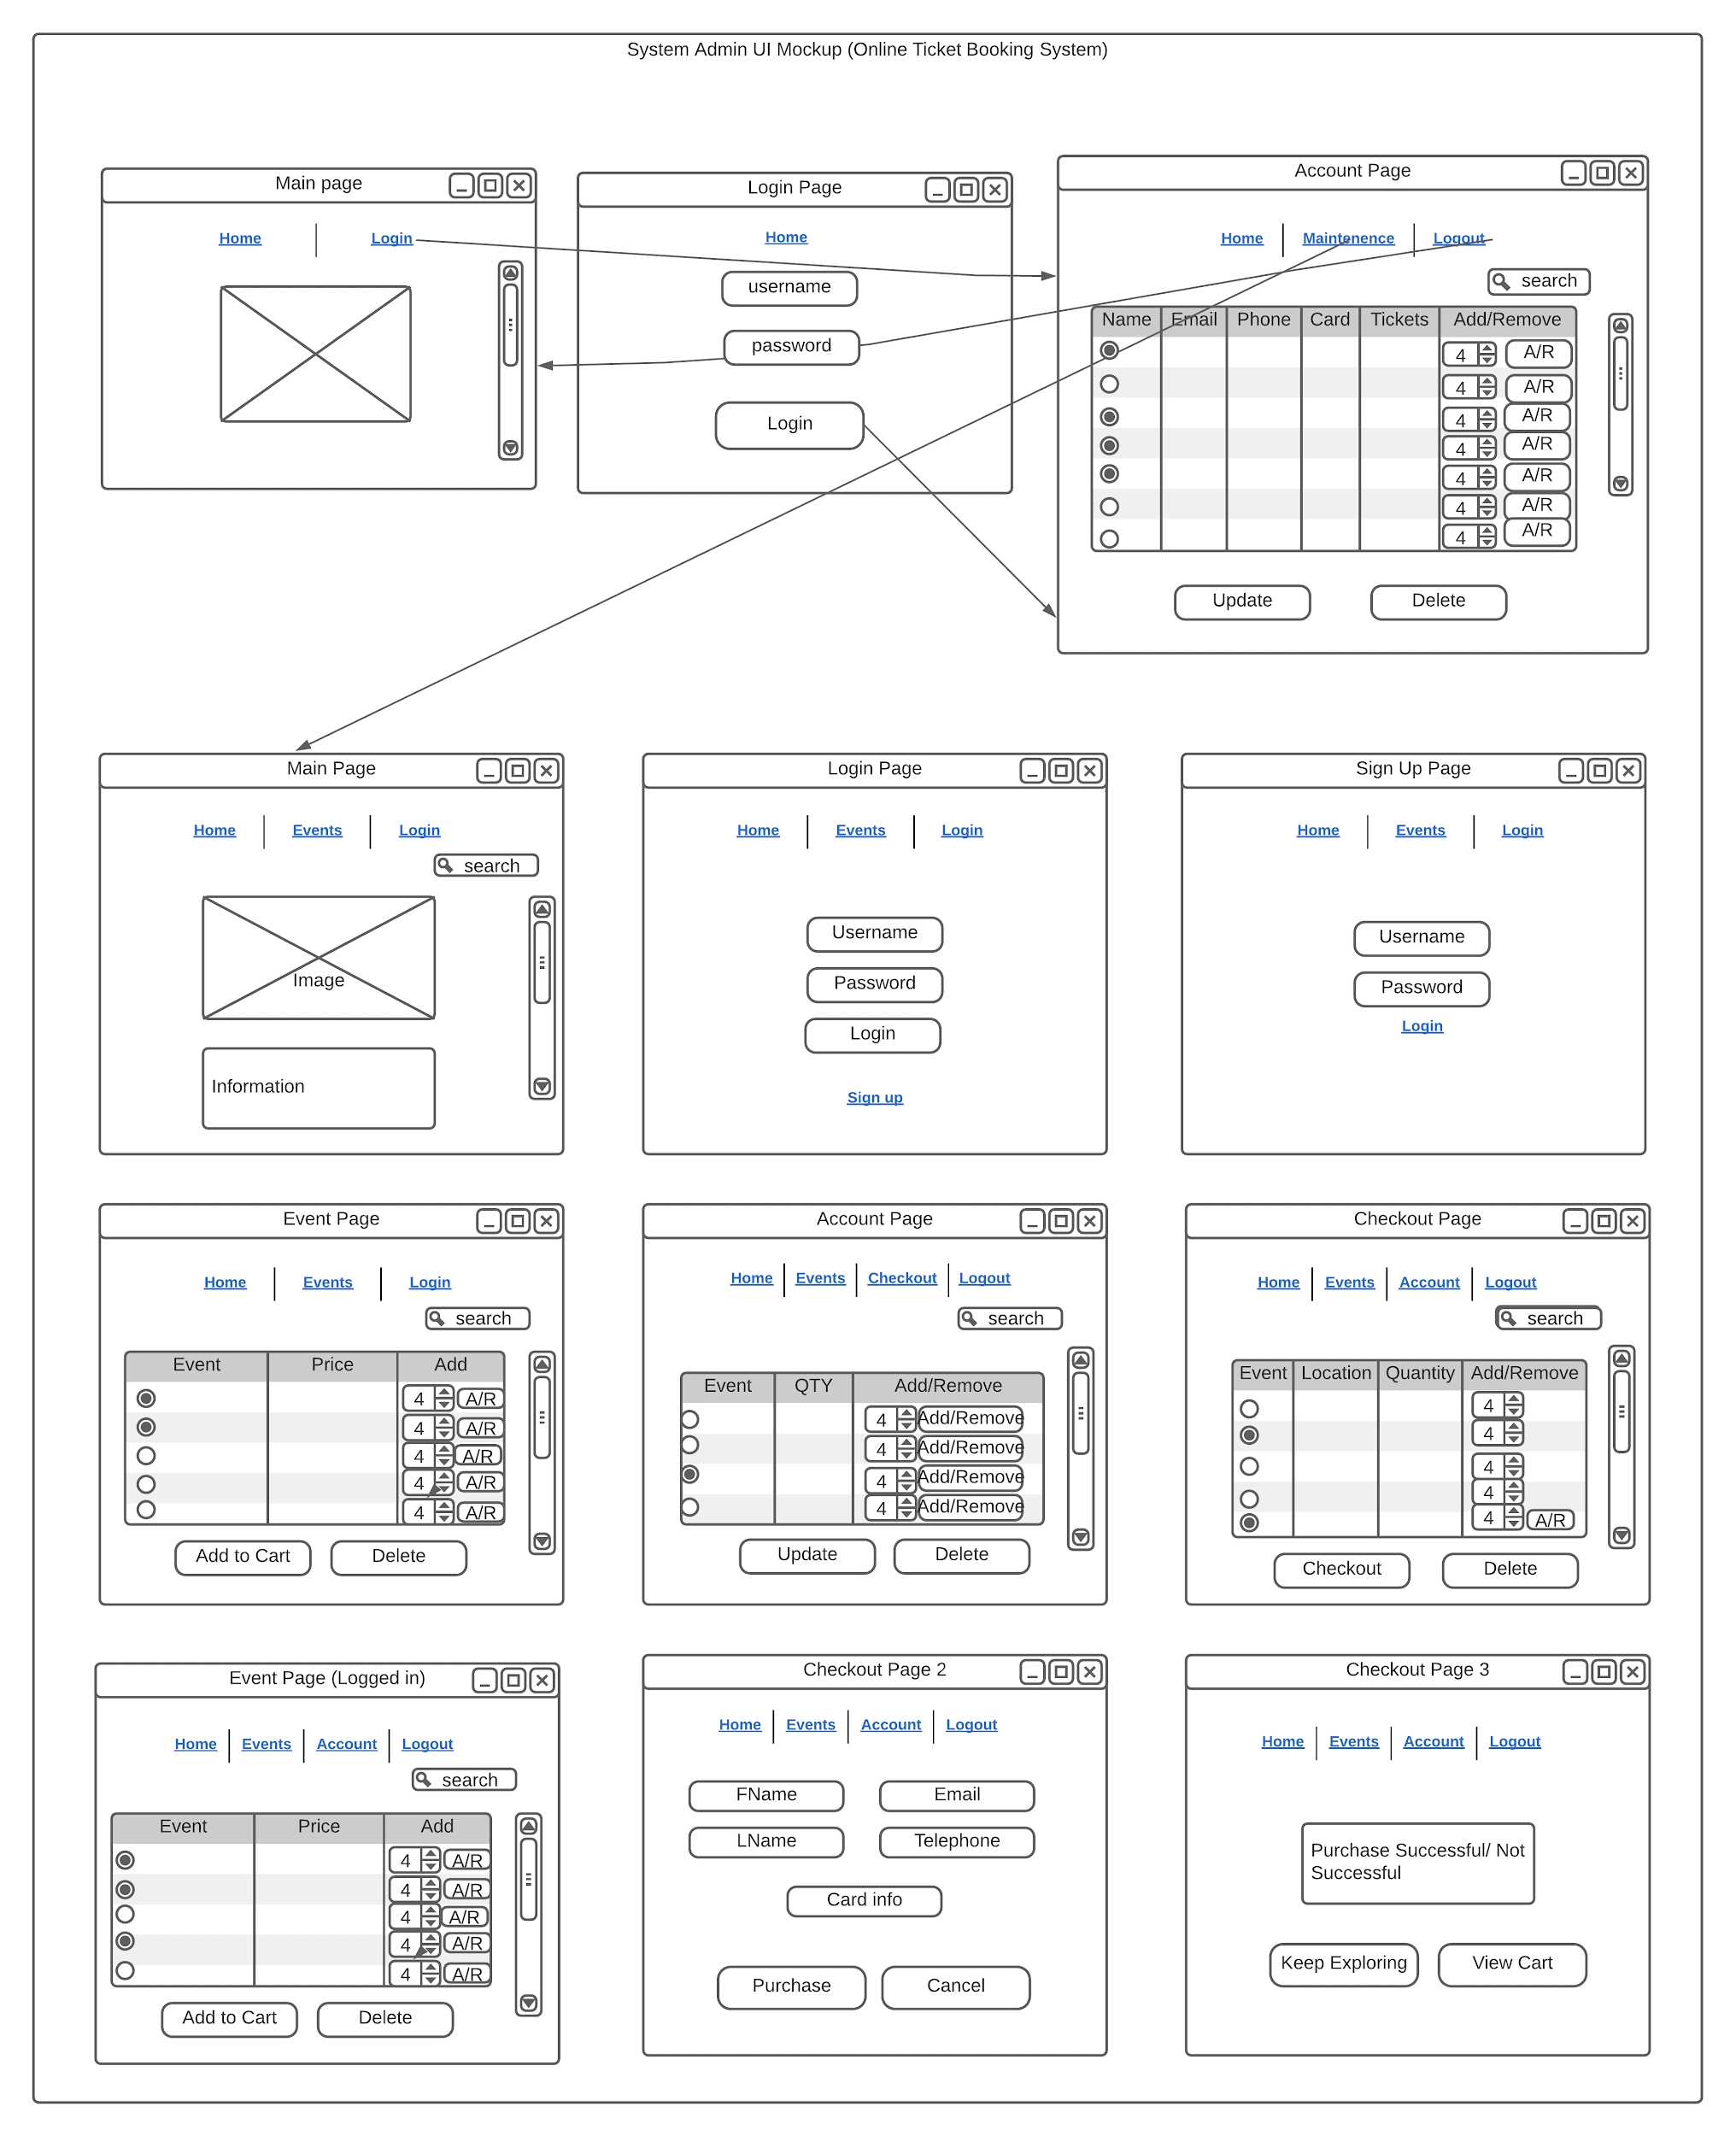**Original UI Design (Admin):**

**Original Structural Design:**

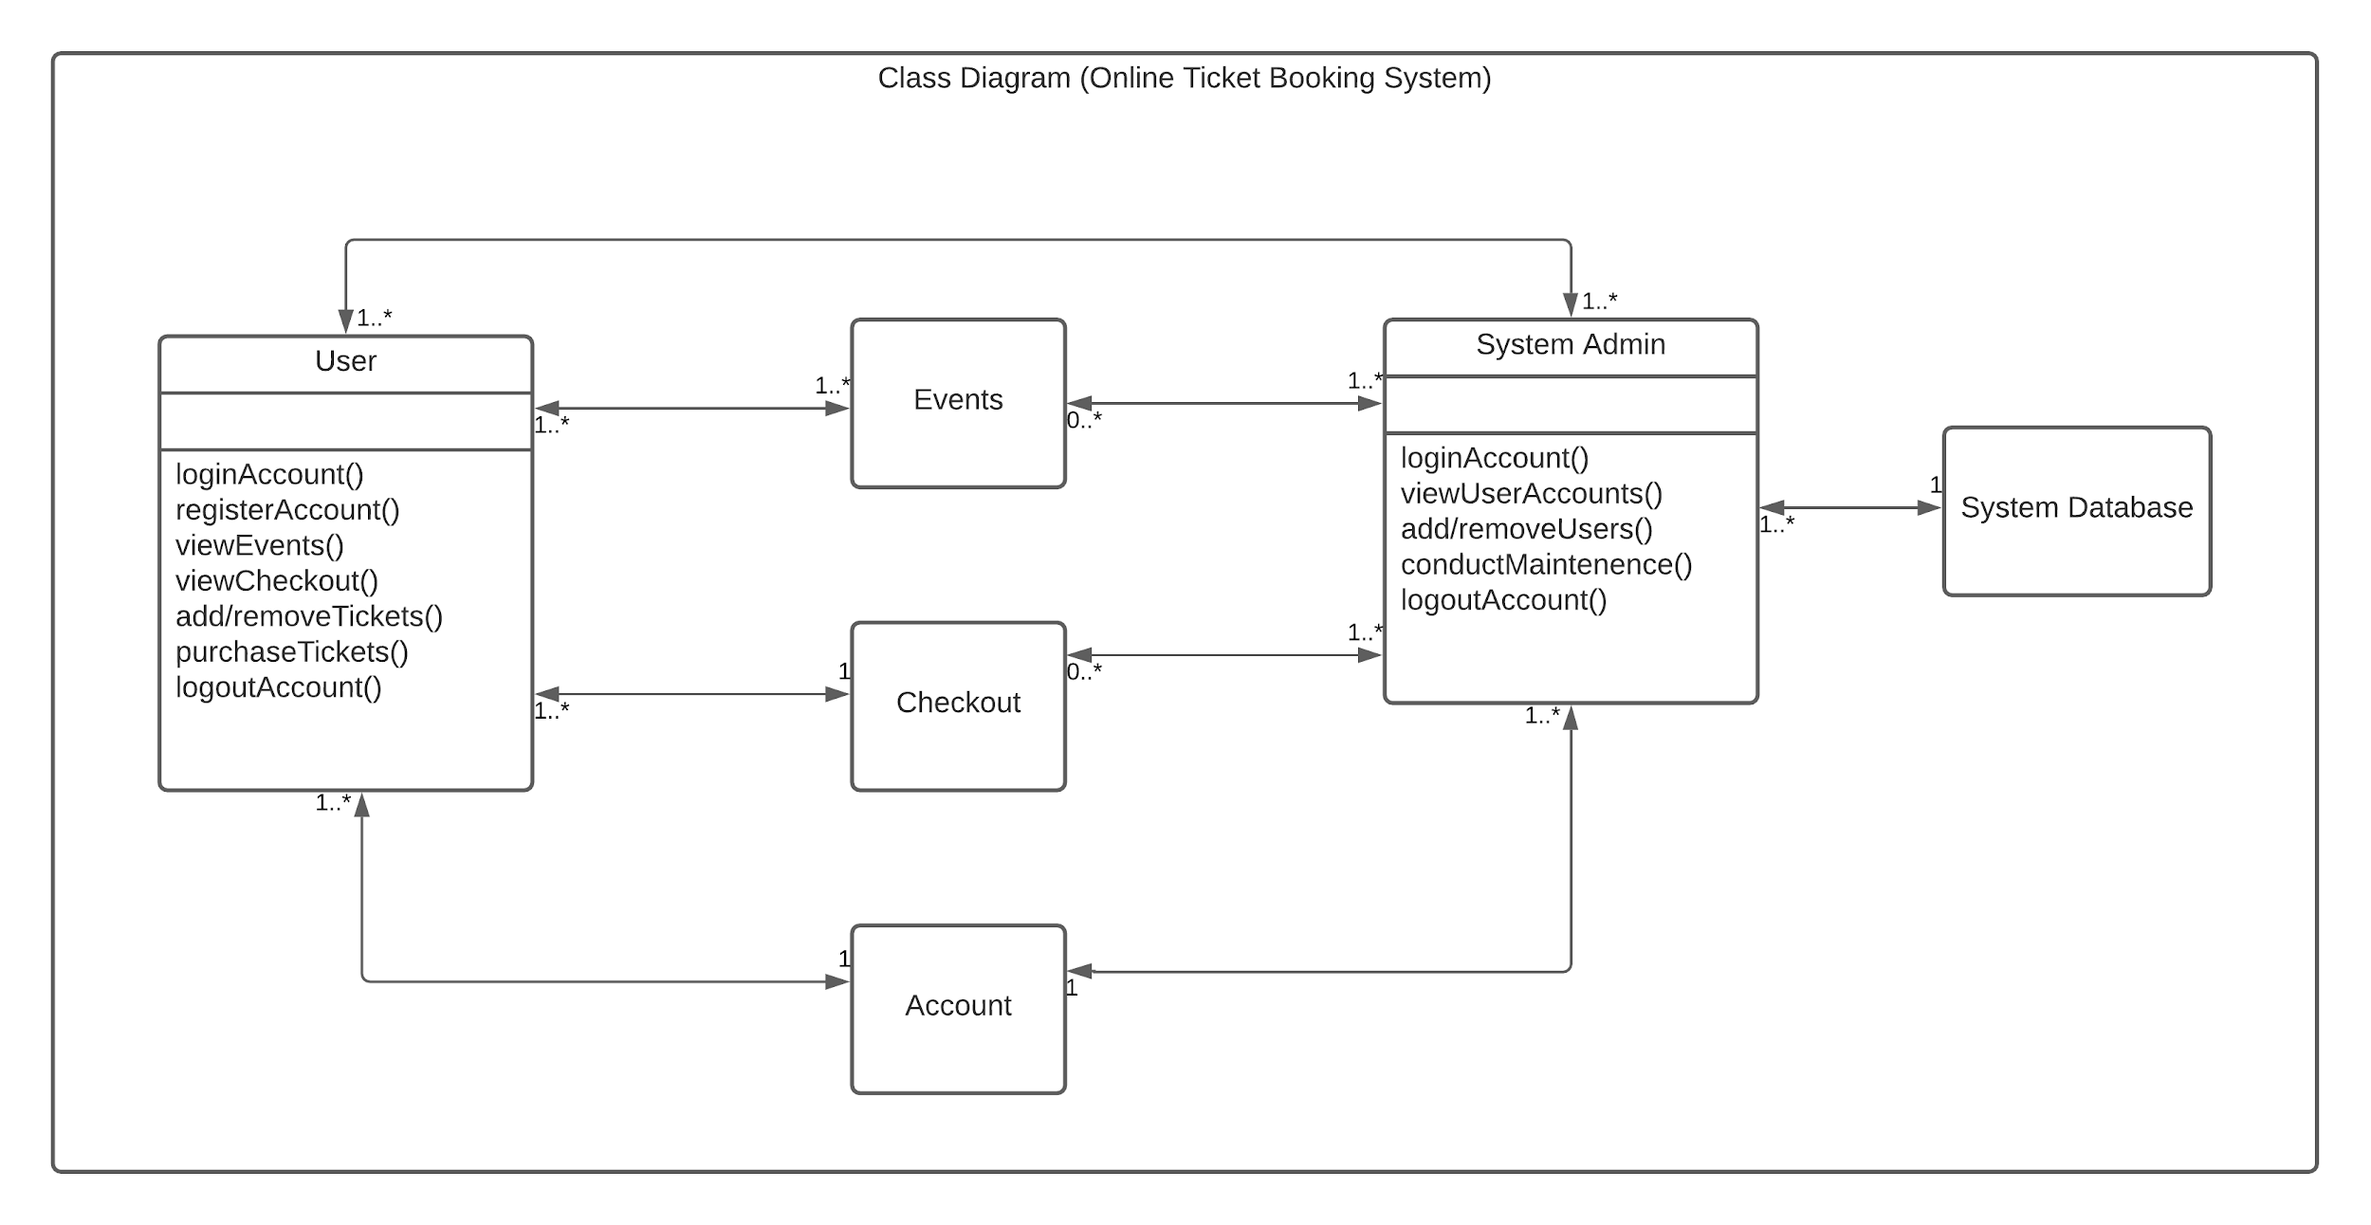

**Changes:**

**Use Case Diagram:**

* Added register page
* Cart page added (checkout)
* System admin only has access to view users/ other admins in database, login/logout – Roadblock with add/ deleting users
* Users can view/ search for event based on name, location, time, price, seating
* Admin can view/search for users based on user id, email, first name, last name, user type(admin/user)

**UI Mockup**:

* Took out add/ remove function for users in event page/ account page
* Took out add/ remove function for admin in account page
* Removed navigation for admin to user browsing areas
* Navbar for users: account, contact, about, cart, logout
* Included footer
* Added Contact + About page to footer
* Contact page: added iframe google maps at footer
* Subtotal/ Total at cart page
* Added register page
* Moved search bar to navbar for user browsing
* Parallax fixed background image
* Bootstrap + fontawesome add to cart/ magnifying glass button modifications
* PhP sessions to track login/logout status, form fields
* Bootstrap table effects

**Class Diagram**:

* Users can only view and add tickets to cart
* Admins can only view users in database – cannot browse user sections

**D. Database Deployment**

For our database aspect design, we utilized "PHPMyAdmin" on the backend to store the information we collected from the user on the front end. Within the database, we created five tables to help store users' information. We created multiple tables so that the user’s data is easily accessible whenever we need it to extract some information. We made sure that our database was highly normalized so that there is no redundant data being repeated on tables when not required. We created a total of five tables within the database which we named booking, the five tables are billing, user, orders, order details, and product. We ensured to give our tables descriptive names to make it easy for us to identify what data each table stores. The image below shows a visual representation of the tables within our database and what attributes and data type each table contains.

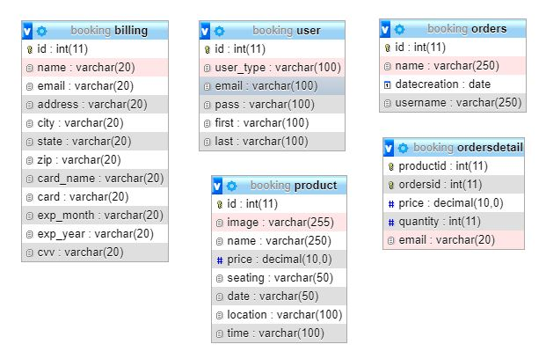

**E. Rollout Plan**

We plan on taking the website to the limits and beyond throughout the testing: Small changes and feature implementation needs to be verified and ensured that it is fully working. We will make sure that our UX and design team iterate through the design to ensure that everything is in place the way it should be. Next, we will ensure that our marketing team and social media team manage the customer-facing content to ensure there are no broken links or images and to make sure all pages load fully as required. We will make sure our entire organization/agency knows about our websites and the features it contains because they would be the best candidates to spread the news. We will also ensure that our customer support team is fully aware of each feature and its functionality, this is to make sure that the days following the launch we are ready to answer and clarify any form of questions the users may have in regards to our website.

We will make sure to share the big news of our brand new website with our customers and do so repeatedly, additionally, we would inform them beforehand how our new website will be different from the old system that we had, what exactly changed and how to use the new systems. We will communicate this through videos and images which we would share through customers’ emails and phones to ensure that every customer is well aware of what’s coming before the launch. We will also include short surveys asking our customers' thoughts on the changes we have made. This information would be useful for us for the next iteration.

We would then launch our website so our customers can purchase their favorite tickets with a very responsive and user-friendly interface in a few clicks following instructions that we have already shared with them.

**F. Communication Plan:**  As it is often said, "communication is key", and this principle applies to us fully. We recognize that in order for us to be on track, we need a steady stream of communication. Amongst the things we plan to have, is very thorough documentation for every one of us to turn to, this documentation will act as a guide on how every bit of our website works and why it is there. Next, we plan on setting clear expectations on when and how updates will be shared. We will communicate ways to obtain feedback from our customers, so we can analyze how they feel about the previous website and satisfy any concerns they may have in our future updates. Furthermore, we will make sure to have recursive team meetings where we can bring ideas to the table and brainstorm new ones. Doing this will ensure that our project is continuously aligned with our goals. Amongst the tools and mediums, we will use for communicating information will include but not be limited to, emails, meetings(virtual and in-person), discussion boards, status reports, Kanban cards, collaboration apps, to-do lists, and surveys. We will use these tools to communicate with stakeholders, shareholders, investors, employees, and our customers, to make sure that we are all on the same page, and whenever there’s an update everyone will be made aware of it in a timely manner.

**G. Training Plan:** We recognize that it is of utmost importance that our employees, stakeholders, and employees have a complete understanding of how our website works. We will first consult the training plan participants and approvers. Conducting such a meeting will help us in figuring out who needs to be trained. We can also utilize previous feedback to identify who needs the training. Next, we will figure out the instructions needed for the training process, we can do this by going through the documentation and outlining every aspect that would need to be trained for. Next, we will create the training plan and review it with applicable stakeholders, the project team, sponsors, and the project owners for accuracy. The following step would involve executing the training plan and making modifications as needed.

**H. Backout Plan**

In the instance where Team Three’s website is unavailable, we will have a backup static website up, where we can still provide information such as company address, customer service phone number and email, frequently asked questions and answers (FAQ), and a list of events available for the current month and the next month. Customers will still be able to contact us, and in the event where our dynamic site is still down, they can email or call us to inquire about any events, or even book a reservation. After the site is fixed, they can either pay through there, or pay in-person at the event venue with their reservation that they booked through email or phone previously. The static website will still need to be updated every month to list the events for the current and next month, which will be part of our IT team’s responsibilities. If it is not updated, customers can still contact us to inquire about any upcoming events, and our customer service team will be happy to inform them.

**I. Business Continuity/Disaster Recovery Plan**

In an instance where there is a technical problem as mentioned in the Backout Plan, we will have a backup static website up, where customers can still contact us and even reserve and inquire about upcoming events. There is also a cybersecurity aspect that is very important to take into consideration. In our previous deliverable, we outlined the roles and teams in our company, which include a cybersecurity team in our IT department. Their responsibilities include backing up important data, which not only include our company’s data but our customer’s/client’s data as well.. This can be done by backing up the data using cloud storage, which is stored digitally instead of using hardware. It is cheaper and efficient for growing businesses, and as an online ticketing company, our data increases every day. For our cloud storage application, we would like to choose AWS, or Amazon Web Services. Using cloud storage, we are able to backup the data daily using daily snapshots. AWS also has great security features, such as multi-authentication, which makes many actions a multi-step authentication process. Multi-authentication can be used to ensure secure log-ins, which would be used by the cybersecurity team members. It can also be used to make sure no data gets deleted accidentally. Cloud storage also has log files, which would allow the cybersecurity team to see any activity or changes to data as well. AWS has many security-focused features that can protect our web application from DDOS attacks, cross-site scripting (XSS) attacks, and can even allow us to block IP addresses. It can also allow the company to manage the users centrally, so that we have fine-grain control of each user and what permissions they have.

**J. Support/Maintenance Plan**

Our current support plan consists of the static website, where customers are able to contact us. Our customer service team will be more than ready to assist customers inquiring about any event or other information. Customers will still be able to see important information such as events for the current and next month and be able to reserve those events through phone or email. Meanwhile, our cybersecurity will work hard to backup the data, which was backed up using cloud storage. Because it is cloud storage and not hardware back-up, it can be faster and easier since we do not need to go off-site. This way, our cybersecurity team can make sure our dynamic website can go up faster, and our customer service team can support us in the meantime. For maintenance, back-ups are done daily, and data log files are updated instantly for cloud storage, meaning any changes that happen can be seen instantly. Cloud storage is good for monitoring activity, and alerts can also be set in AWS if certain thresholds go above or below the desired amounts, such as too much traffic. This way, the cybersecurity team is notified faster, and they can adjust, maintain, and update the website quickly.

**K. Organizational Plan**

Currently there are no new changes needed, any changes that were needed have been implemented already up to this phase.

**L. Future Enhancements**

For the future, instead of having a static back up website, we would like to migrate our website operations fully to AWS. Through AWS, we can create a fully-functioning backup website, or also known as a mirrored website, where customers can resume to use our website as intended. There are also some minor improvements and bugs we would like to do better on:

* Detail page area when clicked on event image
* Add/ delete button for admin
* Order confirmation page modifications (receipt)
* Improved web layout
* Database improvements
* Sort by function viewing events
* Responsive settings for cellphone/ tablets

**Bugs**:

* Error message appears when user click on cart at initial login(without booking tickets)
* Book button missing when user is logged in and searches for event at search page

**Closeout Report - Appendix H (Jackson)**

**Final Updates**

**A. Project Plan**

|  |  |  |  |
| --- | --- | --- | --- |
|  |  |  |  |
| Project Title: | **Online Ticket Booking System** | **Date Prepared: 12/02/2020** | **Project Manager: Jackson Gable** |
|  |  |  |  |
| Goal | **Project Objectives** | **Success Criteria** | **How Met** |
| Scope | Create a specialized user-facing web app that gives users a streamlined experience in purchasing event tickets | Ensure scope is restricted to necessary features of the software | Careful examination of developed features, to ensure they fall within the scope of the project |
| Schedule | Ensure the project is completed by the final deadline set by the project sponsor | Submit all documents, deliverables, and software by December 2, 2020 at 11:59pm | Properly dedicating the time and work required to finish the project on time. |
| Cost | Ensure project costs fall within the budget outlined by the project sponsor | Project may not go over budget | Careful review of budget and cost options by project management team |
| Quality | Ensure the software offers a streamlined experience for users, and is not buggy. | Focus groups must be satisfied with the performance of the software | Extensive unit and integration testing |
|  |  |  |  |
| Lessons Learned Report | |  |  |
| What knowledge area(s) went well, and how this was achieve?  Communication management, scope management, and schedule management went excellently.  The team continuously stayed in touch to ensure project goals were met. | | | |
| What were the project challenges and how they could be addressed on another project?  At first, our communication was a little rocky. But once we discussed which communication channels  worked best for each of us, communication become excellent | | | |
| What would be done different on a similar project?  Discuss availability in the beginning of the project, so that early phase meetings have full  attendance | | | |
| What are the key takeaways about working in an IT project environment?  In IT project management, unforeseen changes can occur quickly. It’s important that the team  have systems in place to manage these rapid changes | | | |

**B. Meeting Minutes**

|  |  |  |  |  |  |  |  |  |  |  |  |  |
| --- | --- | --- | --- | --- | --- | --- | --- | --- | --- | --- | --- | --- |
|  | |  | | | | | |  | | |  | |
| **Meeting/Project Title:** | | **Online Ticket Booking System** | | | | | | **Group Name/No.** | | | **Team 3** | |
| **Meeting Date: (MM/DD/YY)** | | 11/28/2020 | | | | | | **Start Time:** | | | 4:30 PM | |
| **Meeting Type:** | | **Virtual** | | | | | | **End Time:** | | | 5:45 PM | |
| **Facilitator:** | | Daphne Gao | | | | | | **Minutes Taker:** | | | Jackson Gable | |
| 1. **Meeting Objective** | | | | | | | | | | | | |
| **Finalize last presentation, record the presentation, and collaborate to finish the final deliverable.** | | | | | | | | | | | | |
| 1. **Attendance** | | | | | | | | | | | | |
| **Name** | | | **In Attendance (Y/N)** | | | | **Reason for Absence** | | | | | |
| Rudy Bi | | | Y | | | |  | | | | | |
| Cinthia De La Cruz | | | Y | | | |  | | | | | |
| Mamadou Diallo | | | Y | | | |  | | | | | |
| Jackson Gable | | | Y | | | |  | | | | | |
| Daphne Gao | | | Y | | | |  | | | | | |
| 1. **Agenda, Decisions, Issues** | | | | | | | | | | | | |
| **Discussion Notes** | | | | | | | | | | **Discussion led by** | | |
| Discuss format of final presentation | | | | | | | | | | All | | |
| Record the final presentation | | | | | | | | | | Rudy | | |
| Collaborate on final deliverable | | | | | | | | | | All | | |
| 1. **Action Item/Task Assigned** | | | | | | | | | | | | |
| **Activity** | | | | | | **Assigned To** | | | | | | **Due Date** |
| Executive Summary, Deployment Plan, Release Plan | | | | | | Cinthia | | | | | | 12/02/2020 |
| Backout Plan, Business Continuity Plan, Support Plan, Organizational Plan | | | | | | Daphne | | | | | | 12/02/2020 |
| Finalize codebase | | | | | | Rudy | | | | | | 12/02/2020 |
| Database Deployment, Rollout Plan, Training Plan, Communication Plan | | | | | | Mamadou | | | | | | 12/02/2020 |
| Closeout Report, Project Plan, Meeting Minutes, Status report | | | | | | Jackson | | | | | | 12/02/2020 |
| 1. **Next Meeting** | | | | | | | | | | | | |
| **Date:** | N/A | **Time:** | | N/A | **Meeting Type:** | | | | **N/A** | | | |
| **Objective:** | N/A | | | | | | | | | | | |

**C. Status Report**

|  |
| --- |
| **Project Name:** Online Ticket Booking System  **Team Members:** Rudy Bi, Cinthia De La Cruz, Mamadou Diallo, Jackson Gable and Daphne Gao  **Date:** December 2, 2020 |
| **Work completed this past deliverable:**  **-** delegated assigned work for final deliverable  - held a zoom meeting discussing the final portions of the project  - planned and recorded the final presentation  - collaborated to complete the final document deliverable |
| **Work to be completed by next deliverable due date:**   * - TBD – waiting on deliverable guidelines to be provided |
| **What’s going well and why:**   * The team has had excellent communication, and everyone has put in a lot of hard work. We all put in a fair amount of labor into this project   **What’s not going well and why:**  N/A |
| **Suggestions/Issues:**   * Note feedback after project grade is posted, and use it to learn how we can improve our project management skills in our professional lives |
| **Project changes:**   * - Team does not have any planned changes, as this is the final deliverable |

**D. Agile/Scrum Artifacts:**

1. **Product Backlog**

|  |  |  |  |  |  |  |
| --- | --- | --- | --- | --- | --- | --- |
| ***ID*** | ***Product Backlog Item*** | ***User Story*** | ***Completion Time (Days)*** | ***Priority*** | ***Sprint*** | ***Status*** |
| ***1*** | Determine site features and content | As a project manager I want to get a clear picture/idea of overall site design and capabilities | 2 | High | 1 | Done |
| ***2*** | Generate splash page | As a site user I want an uncluttered, user friendly, and easy to navigate website | 2 | High | 1 | Done |
| ***3*** | Login page | As a site user, I want to be able to log into the site so I can buy event tickets | 1 | High | 1 | Done |
| ***4*** | View/create events & user database | As a(n) active employee I want to be able to place on order to purchase on item on the website | 5 | High | 1 | Done |
| ***5*** | Implement site security | As a site user, I want to make sure my information is secure | 3 | High | 2 | Done |
| ***6*** | Device adaptability | As a website developer, I want to make sure site can be reached via multiple devices | 2 | Medium | 3 | Done |
| ***7*** | Payment process | As a site user, I want to be able to quickly and easily pay for my tickets | 2 | High | 2 | Done |
| ***8*** | User info storage | As a site user, I want to be able to save my information for future use and quicker checkouts | 4 | Medium | 2 | Done |
| ***9*** | Banner area | As a marketer, I want to be able to market upcoming events | 2 | Medium | 3 | Done |
| ***10*** | Contact page | As a site user, I want to be able to find contact information on the page in case I need to reach out to site owners | 1 | Medium | 4 | Done |

1. **Sprint Backlog**

|  |  |  |  |  |  |  |  |
| --- | --- | --- | --- | --- | --- | --- | --- |
| Product Backlog ID | Product Backlog Item | User Story | Task | Task Owner | Estimate (Days) | Actual (Days) | Status |
| 2-01 | Create splash page | As an end-user, I want to be introduced with a sleek, welcoming homepage, so that I can recognize the company’s brand while having a streamlined experience | Design business logic | Rudy | 1 | 1 | Done |
|  |  |  | Design UI | Rudy | 1 | 1 | Done |
|  |  |  | Develop back-end | Rudy | 1 | 1 | Done |
|  |  |  | Develop front-end | Mamadou | 2 | 3 | Done |
|  |  |  | Execute unit tests | Rudy | 1 | 2 | Done |
|  |  |  | Execute integration tests | Rudy | 1 | 1 | Done |
|  |  |  | Create documentation | Mamadou | 1 | 1 | Done |

|  |  |  |  |  |  |  |  |
| --- | --- | --- | --- | --- | --- | --- | --- |
| Product Backlog ID | Product Backlog Item | User Story | Task | Task Owner | Estimate (Days) | Actual (Days) | Status |
| 2-02 | Account registration & login | As an end-user, I want to be able to register for and log into an account, so I can have a personalized experience on the web application. | Design business logic | Rudy | 2 | 1 | Done |
|  |  |  | Design data store | Rudy | 2 | 2 | Done |
|  |  |  | Design UI | Rudy | 1 | 1 | Done |
|  |  |  | Develop back-end | Rudy | 5 | 4 | Done |
|  |  |  | Develop front-end | Mamadou | 3 | 3 | Done |
|  |  |  | Execute unit tests | Rudy | 1 | 1 | Done |
|  |  |  | Execute integration tests | Rudy | 1 | 1 | Done |
|  |  |  | Create documentation | Mamadou | 2 | 1 | Done |

|  |  |  |  |  |  |  |  |
| --- | --- | --- | --- | --- | --- | --- | --- |
| Product Backlog ID | Product Backlog Item | User Story | Task | Task Owner | Estimate (Days) | Actual (Days) | Status |
| 2-03 | View event and user data | As an end-user, I want to be able to view events in my area, along with information such as the events’ date, time, ticket price, and location. I want to also be able to look at user data, such as emails, tickets purchased, recurring customers, etc. | Design business logic | Rudy | 1 | 1 | Done |
|  |  |  | Design data store | Mamadou | 3 | 2 | Done |
|  |  |  | Design UI | Rudy | 2 | 2 | Done |
|  |  |  | Develop back-end | Rudy | 5 | 6 | Done |
|  |  |  | Develop front-end | Mamadou | 4 | 3 | Done |
|  |  |  | Execute unit tests | Rudy | 1 | 1 | Done |
|  |  |  | Execute integration tests | Rudy | 1 | 1 | Done |
|  |  |  | Create documentation | Mamadou | 2 | 1 | Done |

1. **Product Increment**

***Product Increment – all Product Backlog items completed during the Sprint and considered “Done” – meets the Definition of Done.***

|  |  |  |  |  |  |  |
| --- | --- | --- | --- | --- | --- | --- |
|  |  |  |  |  |  |  |
| ***Release: 11/30/20*** |  |  |  |  |  |  |
| ***Sprint 2 Done Date:***  ***10/21/20*** | ***Definition of Done***  ***Completions*** | | | | | |
|  | ***Design*** | ***Code*** | ***Testing*** | ***Documentation*** | ***Zero Defects*** | ***Item Usable*** |
| ***Increment:  Product ID’s*** | ***x*** | ***x*** | ***x*** | ***x*** | ***x*** | ***x*** |
| ***Create splash page (2-01)*** | ***x*** | ***x*** | ***x*** | ***x*** | ***x*** | ***x*** |
| ***Account registration & login (2-02)*** | ***x*** | ***x*** | ***x*** | ***x*** | ***x*** | ***x*** |
| ***View Events & User Data (2-03)*** | ***x*** | x | ***x*** | ***x*** | ***x*** | ***x*** |

1. **Burndown Chart:**

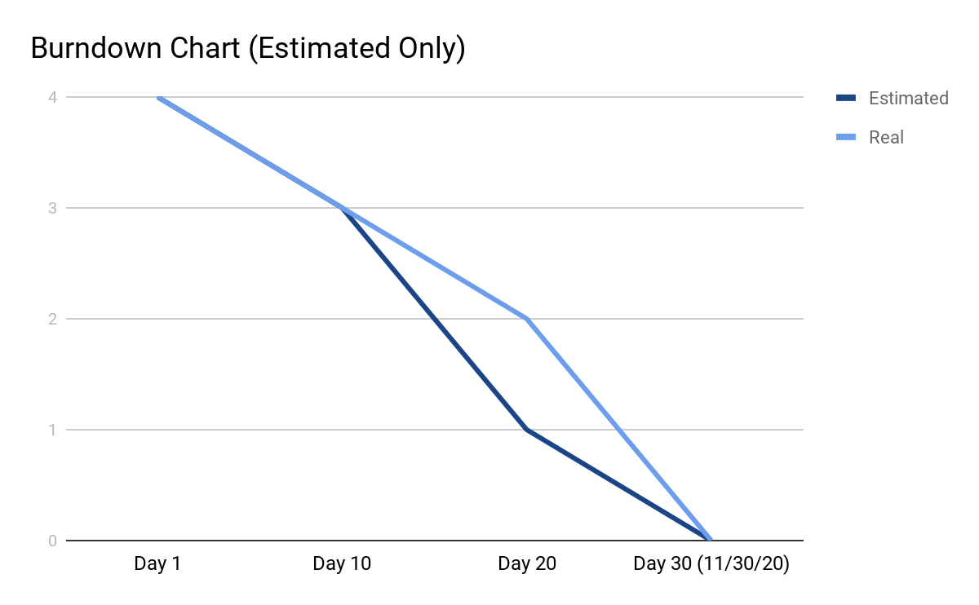

**Product Release & Repository**

Please download the zip file, “Project Submit,” access our final website that we submitted along with this Final Phase Deliverable!

**Appendix A**

**Productivity Report**

|  |  |  |  |  |  |  |  |
| --- | --- | --- | --- | --- | --- | --- | --- |
| Team Member | Tasks Completed | No. of Tasks Completed | Participation = (No. of Tasks Completed ÷ Total No. Tasks Completed) % | Date Tasks Completed | Review Changes | Reviewer Name | Date Review Completed |
| Rudi Bi | * Developed final website layout * Provided all computer programing and coding for site * Provided team with regular site status & updates | 4 | 17% | 11/30/2020 | * Add/ delete button for admin * Order confirmation page modifications (receipt) * Improved web layout * Database improvements * Sort by function viewing events * Responsive settings for cellphone/ tablets | Cinthia De La Cruz | 12/1/2020 |
| Cinthia De La Cruz | * Executive summary and Introduction * Deployment plan parts a-c * Productivity and lessons learned reports * Citations and references * Integrity statement | 5 | 22% | 12/2/2020 | * Updated references to support coding | Daphne Gao | 12/2/2020 |
| Mamadou Diallo | * Deployment plan parts d-g | 4 | 17% | 12/2/2020 |  | Rudy Bi | 12/2/2020 |
| Jackson Gable | * Closeout Report * Final updates a-c & e * Product Release and Repository | 5 | 22% | 12/2/2020 |  | Mamadou Diallo | 12/2/2020 |
| Daphne Gao | * Deployment plan parts h-l * Cover and table of contents page | 5 | 22% | 12/2/2020 |  | Jackson Gable | 12/2/2020 |
|  | **Totals** | **23** | **100%** |  |  |  |  |

**Lessons Learned Report**

|  |  |  |  |
| --- | --- | --- | --- |
| # | Statement |  |  |
|  | What the team did best during the phase?   * Throughout the entire project our team members were able to communicate and discuss our strengths and weaknesses. This led to a fair and productive workload distribution which allowed our deliverables to be completed on time. All team members stepped up when needed and provided additional help when asked. * As a whole, the team was able to gain better comprehension of what it takes to create an interactive website and the different tools needed to build one. We all agreed that computer science (coding) requires great skills and dedication. | | |
|  | What the team could have done better during the phase?   * Because most team members weren’t very knowledgeable in coding, we lacked the capabilities to fully implement all website features. * Scheduled more virtual meetings besides communicating on our team WhatsApp group. We believe that could’ve sped up and helped improve our final report. | | |

**Works Cited**

“Checkout Shopping Cart in PHP.” *Learn Programming with Real Apps*, 8 Jan. 2019,

learningprogramming.net/php-mysql/php/checkout-shopping-cart-in-php/.

Colorlibauthor. “20 Amazing Bootstrap Tables to Organize Data in 2020.” *Colorlib*, 20 Oct. 2020,

colorlib.com/wp/bootstrap-tables/.

"How To Create A Project Management Communication Plan | Teamgantt". *Teamgantt.Com*, 2020,<https://www.teamgantt.com/blog/project-management-communication-plan>.

“HTML.” *W3Schools Online Web Tutorials*, [www.w3schools.com/](http://www.w3schools.com/)

“HTML Footer Template.” codepen.io/scanfcode/pen/MEZPNd..

“IT Disaster Recovery Plan.” *IT Disaster Recovery Plan | Ready.gov*,

[www.ready.gov/business/implementation/IT](http://www.ready.gov/business/implementation/IT).

“MySQL Tutorial.” *Tutorialspoint*, [www.tutorialspoint.com/mysql](http://www.tutorialspoint.com/mysql).

"Training Plan | IST Project Management Office". *IST Project Management Office*, 2018,

[https://uwaterloo.ca/ist-project-management-office/training-plan#:~:text=Purpose%20of%20Tra](https://uwaterloo.ca/ist-project-management-office/training-plan#:~:text=Purpose%20of%20Training%20Plan,and%20schedule%20for%20training%20initiatives)

[ining%20Plan,and%20schedule%20for%20training%20initiatives](https://uwaterloo.ca/ist-project-management-office/training-plan#:~:text=Purpose%20of%20Training%20Plan,and%20schedule%20for%20training%20initiatives).

Legg, Jessica. "Launching Your Website Redesign With The Right Rollout Strategy | Usertesting Blog".

*Usertesting*, 2020.

<https://www.usertesting.com/blog/launching-website-redesign-right-rollout-strategy>.

Santanusantanu 4, et al. “How to Implement a Keyword Search in MySQL?” *Stack Overflow*, 1 June

1958, stackoverflow.com/questions/759580/how-to-implement-a-keyword-search-in-mysq.

Schwalbe, K. (2019). Information Technology Project Management, 9th Edition. Cengage Learning Course

Technology. ISBN: 9781337101356

**Integrity Statement**

**We affirm that the work submitted for the assignment is our own, was not outsourced, or provided by a third party, and all outside sources and references have been cited.**



**Daphne Gao:**

**12/2/2020**



**Mamadou Diallo:**

**12/2/2020**



**Jackson Gable:**

**12/2/2020**

**Cinthia De La Cruz:** 

**12/2/2020**



**Rudy Bi:**

**12/2/2020**